

Low-Level Design

NBA Data Analysis

Vamshi Chowdary

Written by Author 1

Document Version 0.1

Last Revised Date

1. NBA Draft Combine Measurement



**DOCUMENT CONTROL**

Change Record:

Version Date Author Comments

0.1 03-july-2023

Author 1 Introduction

**Approval**

Version Review

Date

Reviewed By Approved

By

Comments

2. NBA Draft Combine Measurement

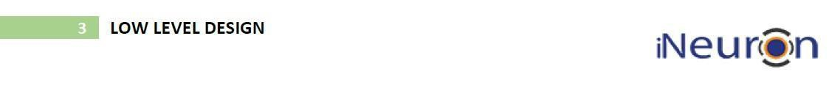

**Contents**

1. Introduction……………………………………………………………………….. 04

1.1 What is Low-Level Design Document? ………………………………….... 04

1.2 Scope …………………………………………………..…..…………….... 04

2. Architecture …………………………………………………….….…………...… 05

3. Architecture Description …………………………………………………………. 06

3.1 Data Description………………………………………………………… 06

3.2 Web Scraping …………………………………………………………. 07

3.3 Data Transformation ………………………………….………………… 07

3.4 Data insertion from csv files ……………………………………………07

3.5 Representation of results using python libraries ……………………. 07

3. NBA Draft Combine Measurement

**1. Introduction**

**1.1 What is a Low-Level design document?**

The goal of the LDD or Low-level design document (LLDD) is to give the internal logic design of the actual program code for the House Price Prediction dashboard. LDD describes the class diagrams with the methods and relations between classes and program specs. It describes the modules so that the programmer can directly code the program from the document.

**1.2 Scope**

4. NBA Draft Combine Measurement

Low-level design (LLD) is a component-level design process that follows a step-by-step refinement process. The process can be used for designing data structures, required software

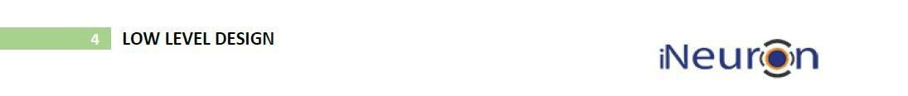

architecture, source code, and ultimately, performance algorithms. Overall, the data

organization may be defined during requirement analysis and then refined during data design work.

5. NBA Draft Combine Measurement



**2. Architecture**

**Plotly Server Architecture**

Almost every Data Science project requires some kind of visualization, like visualizing the input data, exploratory data analysis using histograms or scatter plots, finding outliers or plotting statistics using box and whisker plots, visualizing the relationship between nodes using network diagrams, checking the relationships between variables using correlation matrices, visualization techniques to help understand relationships within high-dimensional datasets, visualizing the performance of the models, or the train history, etc.

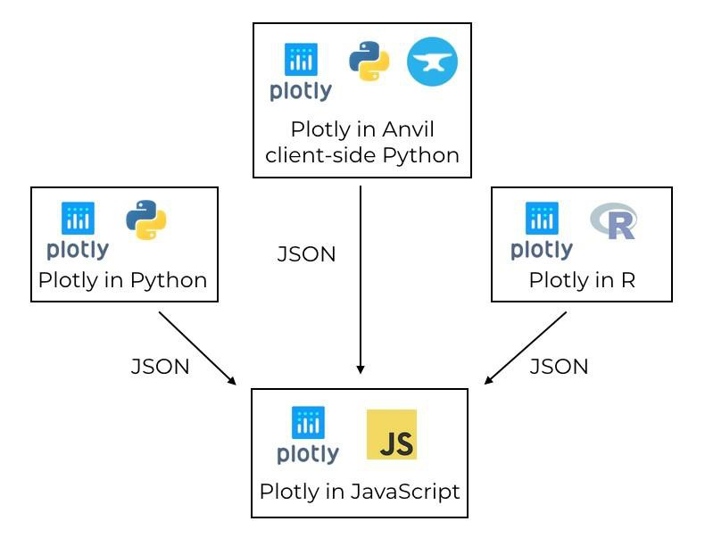

**Tableau Server Architecture**

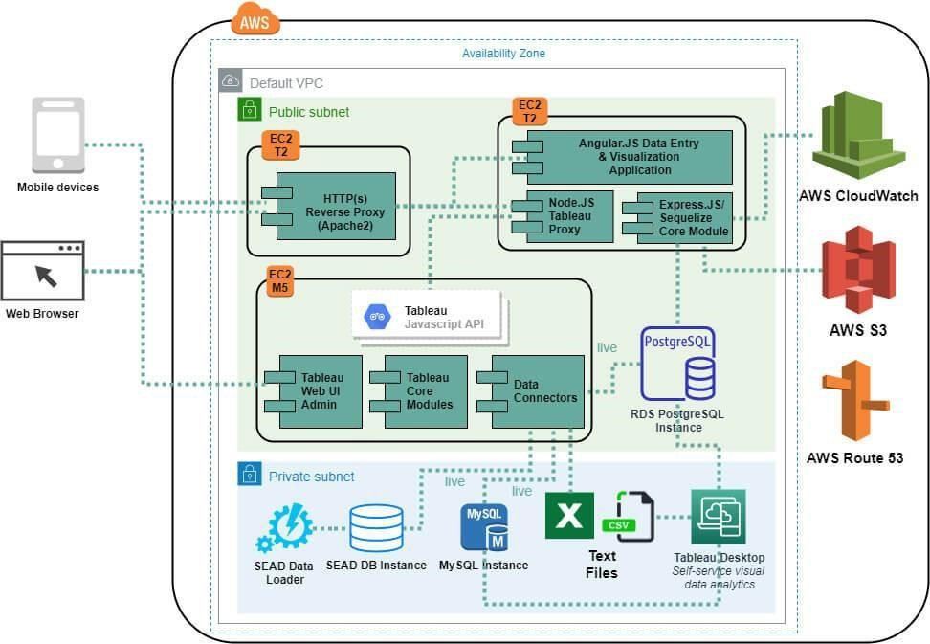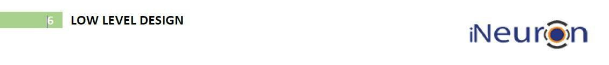

6. NBA Draft Combine Measurement

**Tableau Communication Flow**

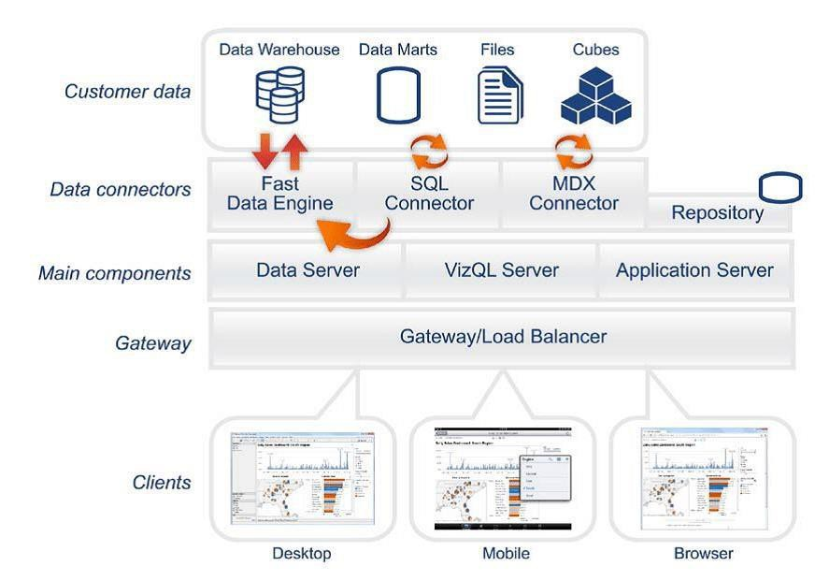

Workflow of Tableau

**3. Architecture Description**

**3.1. Data Description**

The data set contains:-

Draft Pick

Vertical(max) Vertical(max reach) Vertical(no step)

Vertical(no step reach)

weight body fat

bench agility sprint

, etc. of the NBA players.

1. Year – In which year the player played the match (in integer).

2. Body Fat - player’s fat on his body (in float)

7. NBA Draft Combine Measurement



3.Wingspan - player’s wingspan (in float)

4.Sprint - player’s sprint value (in float)

5.Bench - player’s bench value (in float)

6.Standing Reach - player’s standing reach value (in float)

7. Agility - player’s agility value (in float)

8. Draft pick – player’s draft pick value (in float)

9. Weight –Player’s weight (in float)

**3.2. Web Scrapping**

Web scraping is a technique to automatically extract content and data from websites using bots. It is also known as web data extraction or web harvesting.

Web scraping is made simple nowadays, many tools are used for web scrapping. Some of the python libraries used for web scrapping are Beautiful Soup, Scrapy, Selenium, etc.

In the Transformation Process, we will convert our original datasets with other

necessary attributes format. And will merge it with the Scrapped dataset.

**3.4. Data Insertion from CSV files**

1. Download the dataset from open sources (Kaggle) or GitHub and store it in your local system where you can easily access it.

2. Import important libraries required for viewing the dataset in your local IDE.

**3.5 Representation of results using python libraries**

8. NBA Draft Combine Measurement

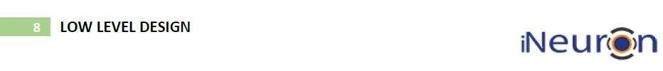

**Step 1. Configuring Pandas, Numpy, Matplotlib, Seaborn**

Launch Jupiter on your local system and import the libraries as shown in the picture.

**Importing Libraries**

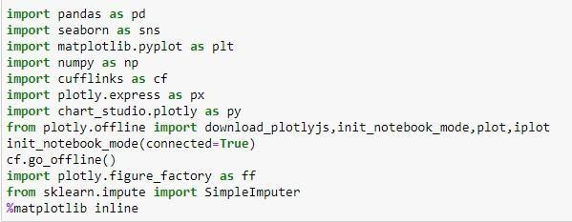

**Height (No Shoes With Vertical (Max)**

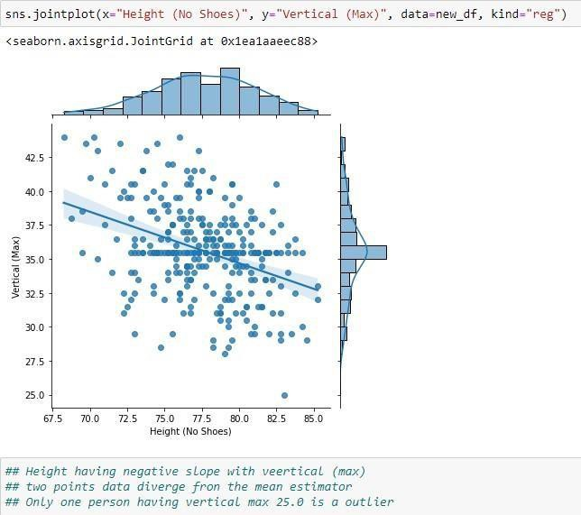

9. NBA Draft Combine Measurement

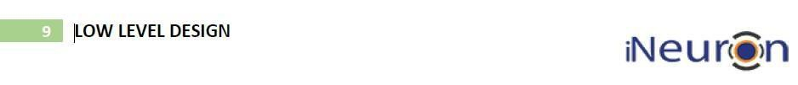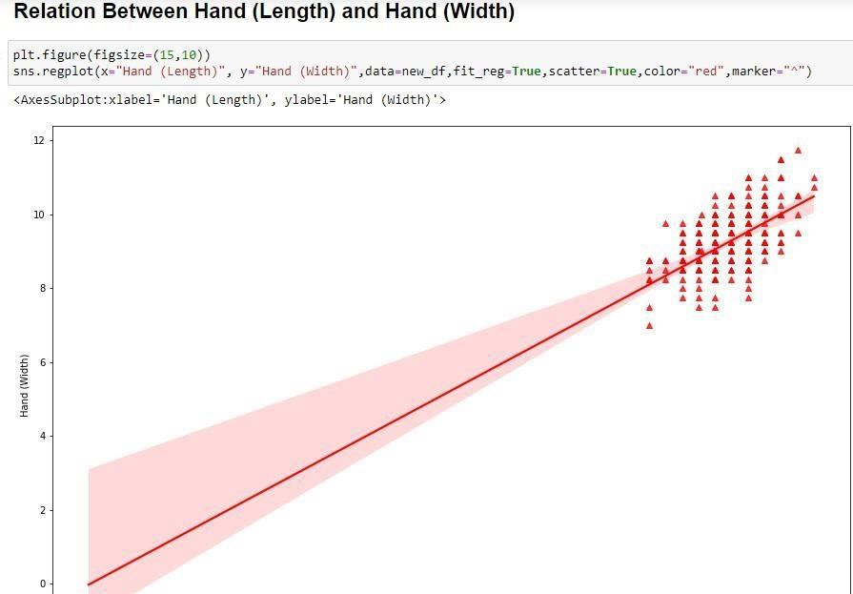

You need to initiate the Plotly Notebook with **init_notebook_mode** to use Plotly

in the local environment**,** also note that when you call py. The plot is still calling the plot function from the online Plotly module, you need to import the **iplot**(not

plot) from **plotly. offline** and use it for offline plots and inside notebook rendering.

The cufflinks library binds the power of plotly with the flexibility of pandas for easy plotting cufflinks.

**Step 3. Import plotly express**

10. NBA Draft Combine Measurement

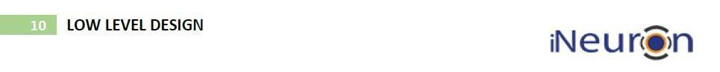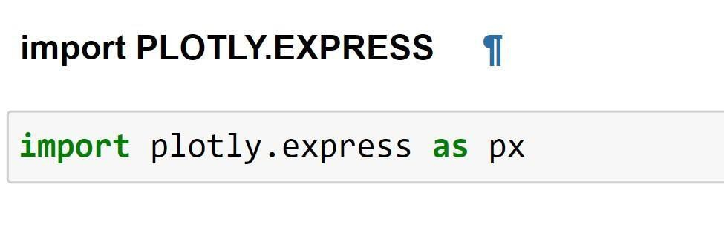

To use the Plotly express we need to first import plotly. express and we can call different graphs of plotly. express.

9 . NBA Draft Combine Measurement



Installation

plotly may be installed using pip:

$ pip install plotly==5.8.0 or conda:

$ conda install -c plotly plotly=5.8.0

**Step 4: Configuring Data Source**

**Importing and Combining All Dataframe**

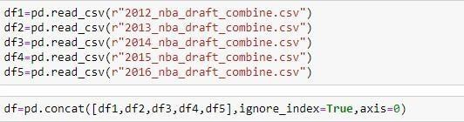

The data can be found from open source and can be imported and merged using pandas.

**Step 5: Deployment**

Once we have completed all the coding parts, then it’s time to deploy our model and check the result.

